Microsoft Word 97 Outlook Message Class Document

Description
USE OF THIS DOCUMENT ASSUMES YOU ARE FAMILIAR WITH DESIGNING CUSTOM OUTLOOK FORMS. This Microsoft Word 97 document uses Visual Basic for Application automation to change the message class for all items in a Microsoft Outlook folder. With Outlook, you can create a new form for items such as Contacts and set the folder's property so that all new Contacts use the new form. However, old Contacts will still use the old form. The Omsgclas.doc document allows you to change the message class of each item in the folder so that all existing items will use a specific custom form. In addition to Contacts, this solution works with other Outlook item folders.

Note that this utility has been designed for Microsoft Outlook 97 and Outlook 98 (versions 8.0, 8.01, 8.02, 8.03 and 8.5). Using this utility on future versions of Outlook may cause unpredictable results.

Installation
Open the Word 97 document file (Omsgclas.doc)

Before You Start
Before using the macro, you should know the name of your new form. You can find the name of your custom form by opening a new item based on the form in Outlook and then on the File menu, click Properties. The name of your form appears under the General tab next to "Type."

The following table shows the default Outlook Message Classes:
Item | Default folder | Default Message Class
Contact | Contacts | IPM.Contact
Task | Tasks | IPM.Task
Appointment | Calendar | IPM.Appointment
Note | Notes | IPM.StickyNote
Journal Entry | Journal | IPM.Activity
Mail | Inbox | IPM.Note

Starting the Macro
The macro will start automatically every time you open the Omsgclas.doc file. If you are prompted with a macro virus warning dialog box, select the option that will enable the macro to run.

Using The Macro
When you start the macro, you will see the following dialog box:

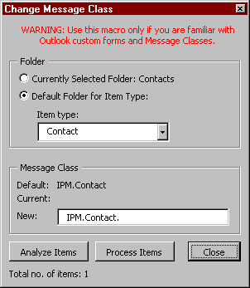

Under Folder, click to select the folder that contains the items that you want to change. Click Analyze Items to determine the current message class for items in this folder. The Analyze feature displays a maximum of 10 different message class values. In the New box, type the name of the new message class for this folder. For example, if you have a new Contact form named MyForm then type IPM.Contact.MyForm in the New box. Note: The IPM.Contact. already appears. Click Process Items to change all items in the folder to the new message class. Click Close when you are finished.

You can repeat this process as many times as you like. For example, to change the message class back to the default, type IPM.Contact in the New box and click Process Items.

