Literature Fulfillment
How to Schedule a Media Kit Mailing for the Literature Coordinator

1. Lookup the record you would like to send the mailing to

2. Select from the top bar menu, Contact, Schedule To-Do (Ctrl+T or )

3. Fill in the Time you need it done by
Specify the Priority, if High
Select Schedule For: (Coordinator name)

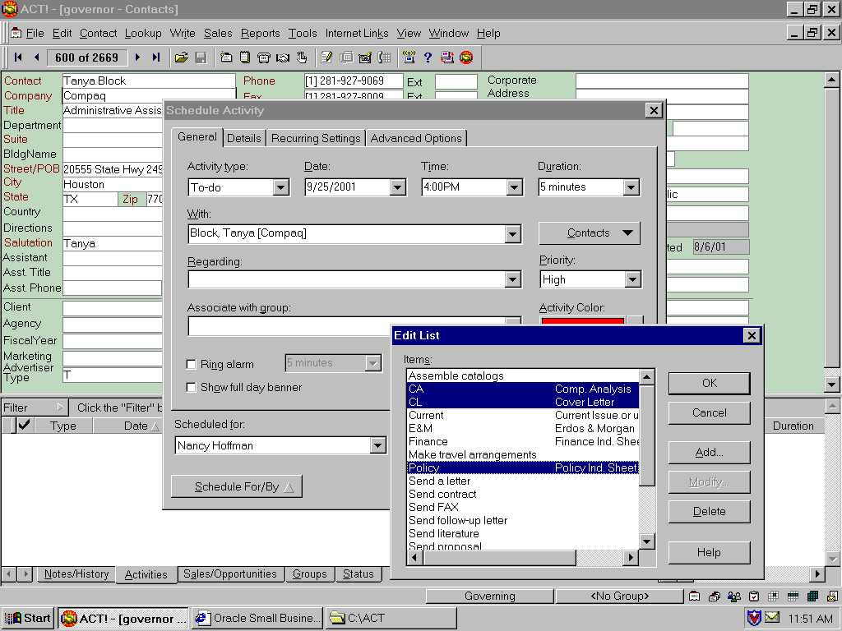
Tip: When selecting the Regarding, you may press F2, then select multiple items
by holding down the Ctrl key as you click on the Items.

Select OK
This is how it will look after specifying the To-To for the Coordinator.
It will be listed in the Activities tab.

If you need to make any changes, you may double click on the grey box to the left of the Activity. Then you will see the same dialog as you did when first entering the activity.

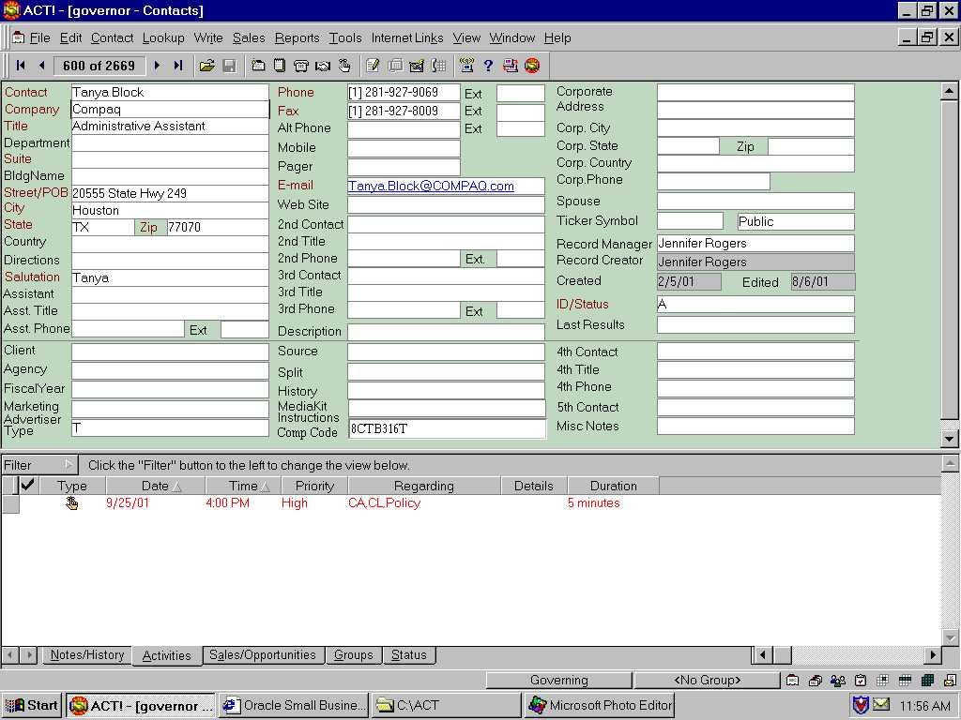

The Media Kit entries are:

CA = Comp. Analysis
CL = Cover Letter
Current = Current Issue or use a month
E&M = Erdos & Morgan
Finance = Finance Ind. Sheet
Harvey = Harvey Report
Policy = Policy Ind. Sheet
Ship = how to ship: 2D=2nd day, ON=OverNight
Special = Latest promotion
TP2 = The Public Purchaser
Tech = Technology Ind. Sheet
Coordinator Task List

The Coordinator will see the following on the View Task List screen.
The Select Users… button will allow the Coordinator to view activities scheduled.
The Tasks can be selected to show
To-do’s only
High priority only
Today only
Selected Users: (Coordinator name)

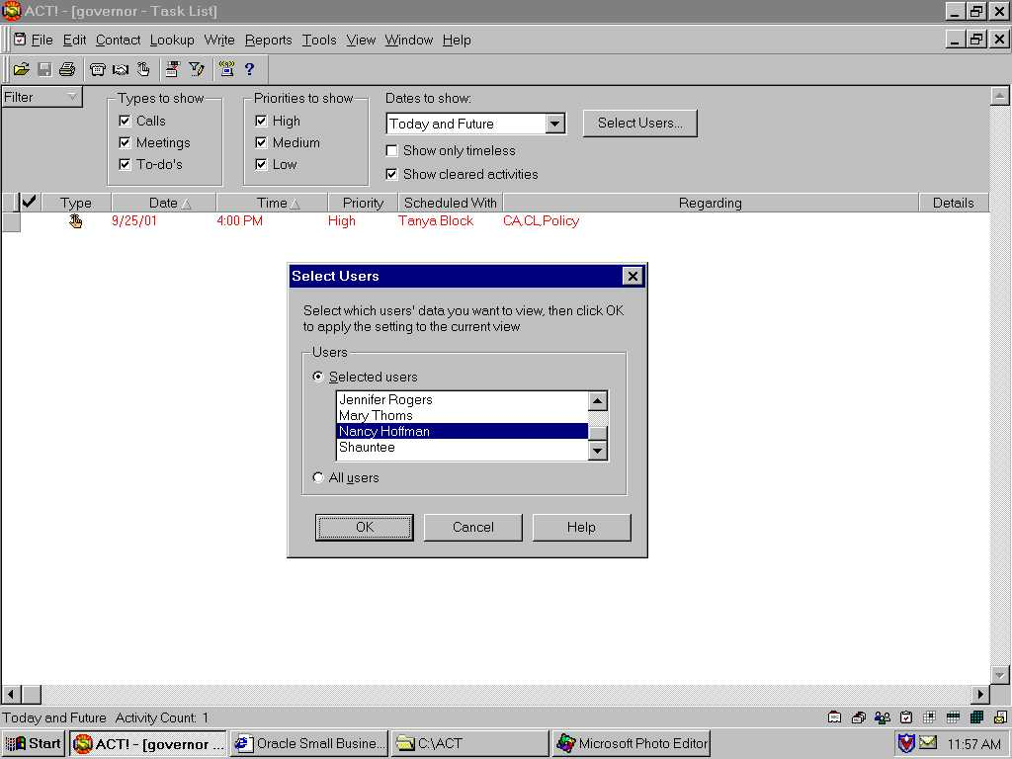

Upon sending the requested items, the Coordinator marks the task as completed by simply clicking below the Check mark in the left column, then pressing Enter.

The next day, the Representative will see that this Activity has been accomplished by looking in the contact’s History

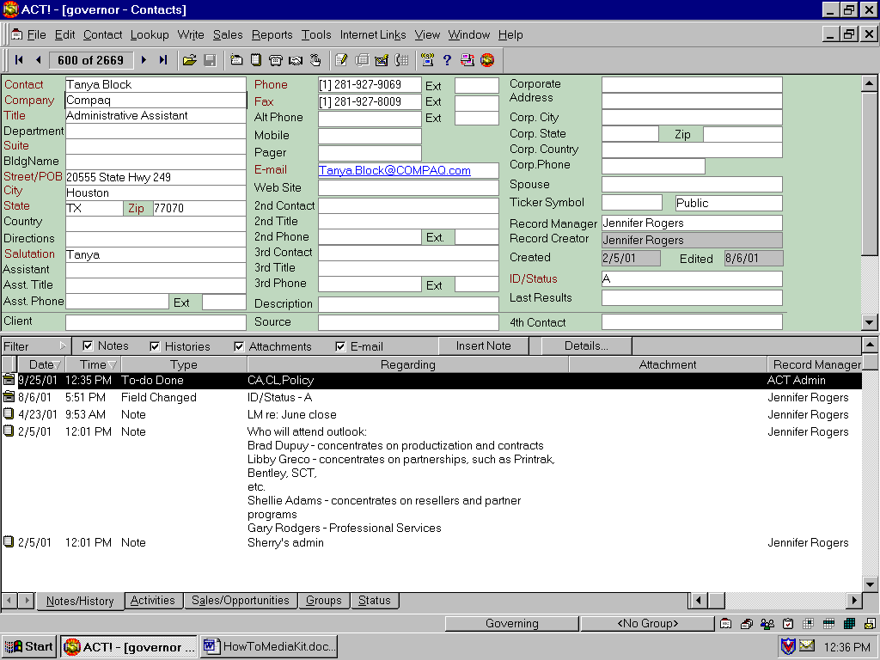
Another place to see that it is done is the Activities tab (if “Show cleared activities” is enabled)

