How to Synchronize

Synchronization is the process of integrating the databases from individual desktops or laptops into a central database.

Step 1: From the ACT! Screen, select the tool bar icon of the two computers communicating. This is the right-most icon on most computers.

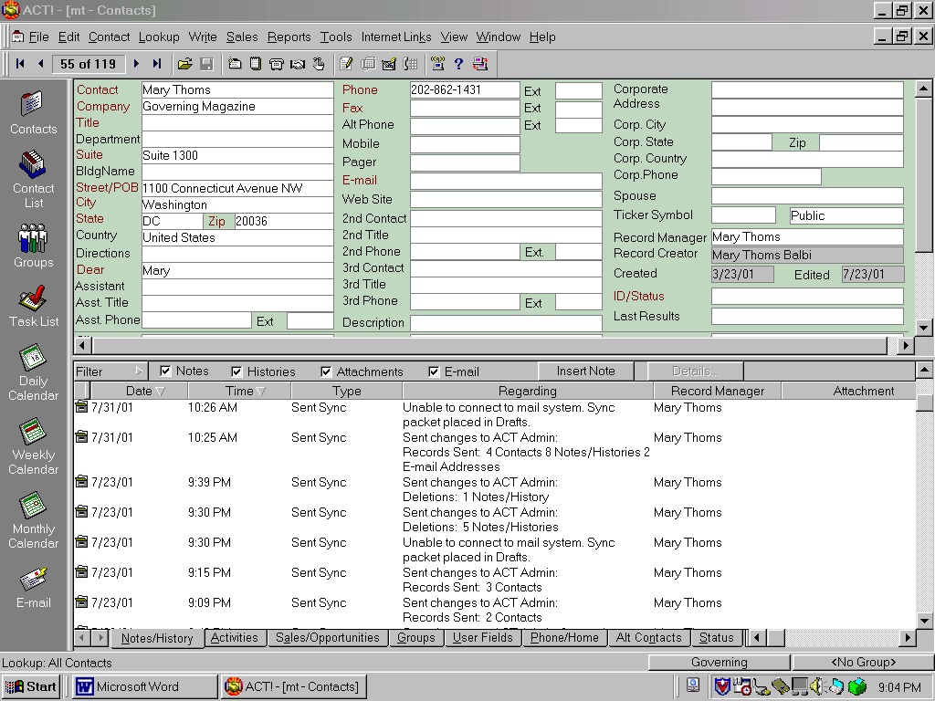

You will see the following dialog pop up.
At this point the Reps will only need to Send update
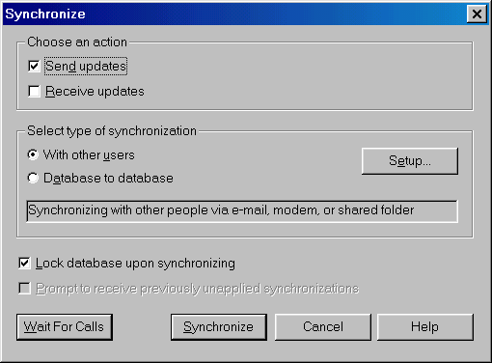
Select the Synchronize button

(Later on we may get in to two-way synchronization.)

This dialog pops up from Microsoft Outlook
as a security measure. You can check “Allow access for 1 minutes”
then select “Yes”
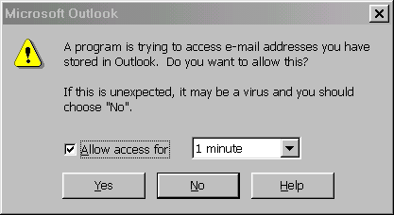
You will then see the following activity for a minute or two,
Depending on how many changes have transpired
since the last synchronization.

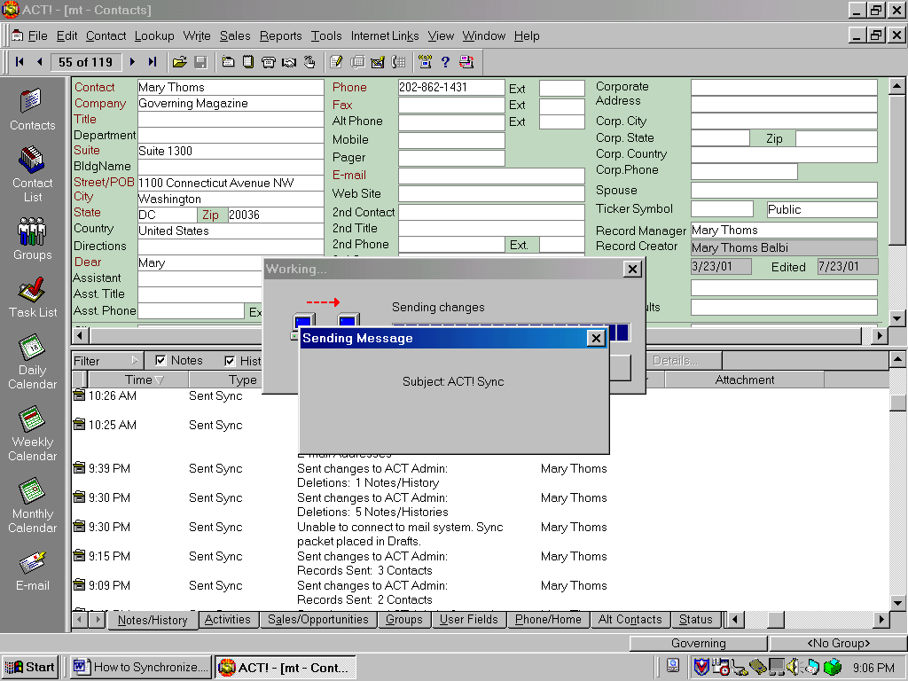

It is suggested that you Synchronize at least once a day.
It does not hurt to synchronize too often.

This will help Governing Magazine enjoy greater progress through synergy
of its information base.

